DATA SCIENCE AND
VISUALIZATION
WEEK 8 FINAL PROJECT REPORT
Autoimmune Disorder Analytics
Building an Interactive Streamlit Dashboard with Plotly
Patient Insights • Clinical Exploration • Disease Prediction
SUBMITTED BY | TEAM 12
NIVETHA S (25BAD074)
POOJA T (25BAD077)
PUVIPRIYA M (25BAD084)
VAISHNAVI D (25BAD126)
DAISY RANI S (25BAD505)
Course: Data Science and Visualization
Academic Year: 2026–2027

Abstract
This project develops an interactive dashboard for exploring an autoimmune-disorder dataset using Streamlit and Plotly. The application brings data summaries, diagnosis distribution, age distribution, symptom patterns, selected clinical and antibody features, and an interactive disease-category prediction interface into a single navigable experience. It uses the Week 6 age-restored feature-engineered dataset, containing 12,500 records across 116 diagnosis categories. The dashboard communicates patterns in the data while presenting predictions as educational output rather than clinical diagnosis.

1. Introduction
Health-related datasets contain demographic, symptom, laboratory, and antibody-marker variables. Exploring them separately can make relationships difficult to understand. An interactive dashboard offers a unified visual interface, guiding the user from an overall dataset view to focused symptom and clinical analysis, and finally to the prediction screen.

2. Objectives
- Build a multi-page Streamlit dashboard with sidebar navigation.
- Summarize dataset size, diagnosis count, age, and symptom features.
- Visualize diagnosis frequency and patient-age distribution using Plotly.
- Explore symptom frequency and patterns across diagnoses.
- Compare selected clinical and antibody/protein features across diagnosis groups.
- Provide an interactive disease-category prediction interface.
- Use a consistent design and clearly communicate educational-use limitations.

3. Tools and Technologies
Tool / Library | Purpose
Python | Dashboard logic and data processing
Pandas & NumPy | Loading, cleaning, aggregation, numerical operations
Streamlit | Layout, navigation, tabs, input controls, metrics
Plotly Express | Interactive bar charts, histograms, box plots, heatmaps
Scikit-learn | Preprocessing pipeline, Random Forest classifier, evaluation utilities
GitHub-hosted CSV | Week 6 age-restored feature-engineered dataset source

4. Dataset Description
The application loads the Week 6 feature-engineered dataset with age restored from a GitHub raw CSV. The sidebar identifies the dataset as “Week 6 Age Restored.”
Dataset item | Value
Total records | 12,500
Diagnosis categories | 116
Target variable | Diagnosis
Patient age | Age (years)
Feature groups | Demographic, selected clinical/antibody features, and 10 symptoms

Selected model/analysis features include ACPA, CRP, Sickness_Duration_Months, Hemoglobin, RBC_Count, ESR, Hematocrit, MBL_Level, Esbach, and ANA, alongside age, gender (when available), and symptom inputs.

5. Dashboard Design: Building the Narrative
The dashboard follows a progressive story: orient the user to the dataset, reveal symptom-level patterns, inspect clinical and antibody measurements, and then explore the prediction interface. Sidebar navigation stays consistent across pages. A light background, blue palette, clear headings, and Plotly interaction controls support readability.

5.1 Overview — Start with the big picture
The Overview page introduces the dataset through summary metrics and two charts. The horizontal bar chart ranks the top 10 diagnosis categories after removing the Normal category; the histogram shows patient-age distribution. A dataset preview supports inspection of individual records.
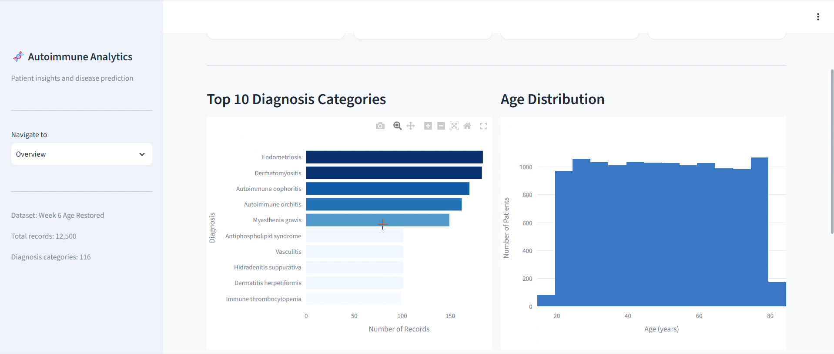
Figure 1. Overview: Top 10 diagnosis categories and age distribution.

5.2 Symptom Analysis — Move from counts to patterns
The symptom page summarizes the percentage of patients reporting each of the ten symptom features. A diagnosis-by-symptom heatmap supports comparisons among frequent diagnosis groups. Together, the visuals move from an overall frequency ranking to patterns across categories
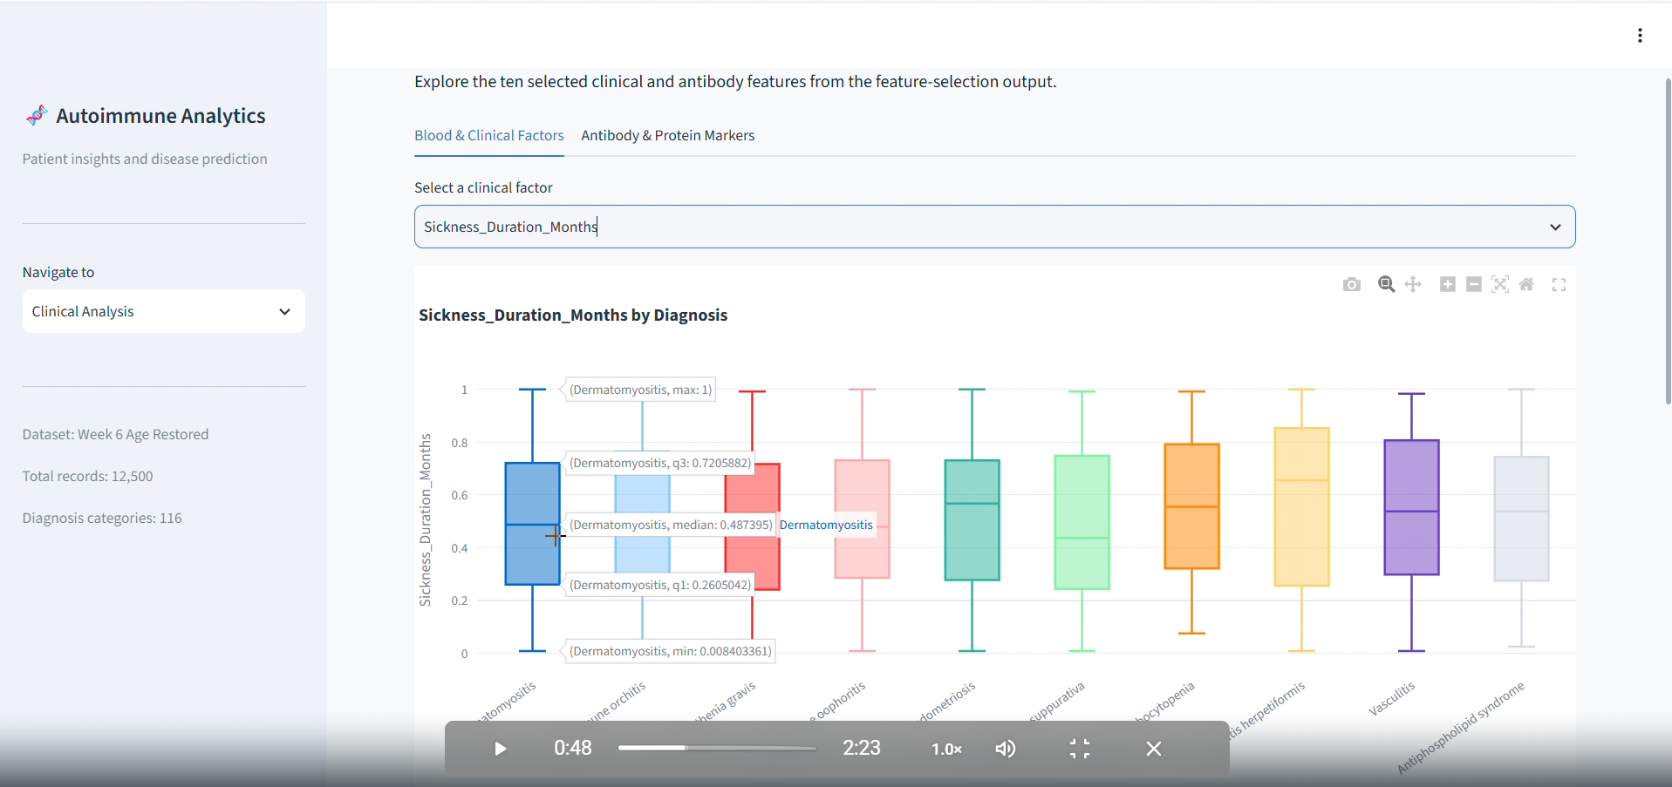
Figure 2. Interactive clinical-feature exploration by diagnosis.

5.3 Clinical Analysis — Inspect selected measurements
The Clinical Analysis page separates Blood & Clinical Factors from Antibody & Protein Markers using tabs. A dropdown selects a feature; Plotly box plots show its distribution across diagnosis groups. This design avoids overcrowding the page with all variables simultaneously
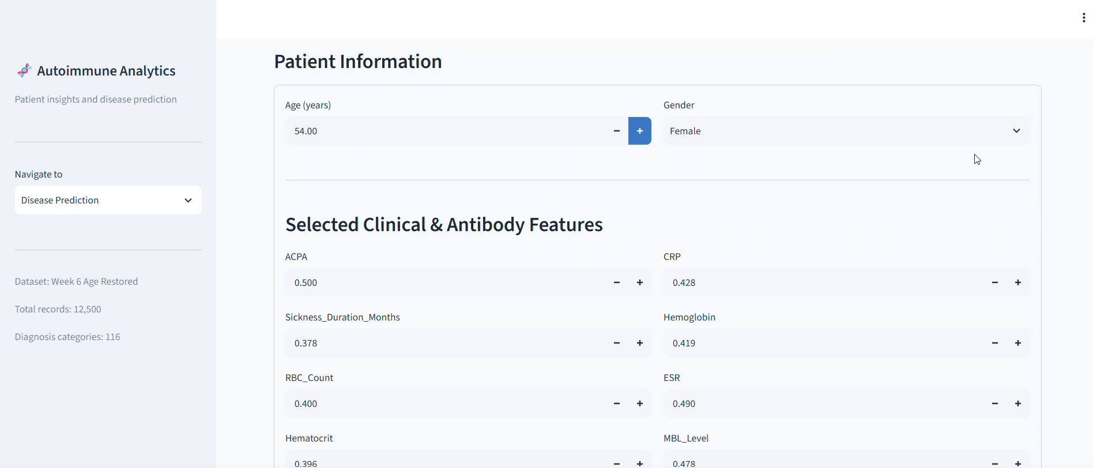
Figure 3. Patient information and selected clinical/antibody feature controls.

5.4 Disease Prediction — Inputs and output
The prediction page collects age and gender, selected clinical and antibody feature values, and symptom responses. After “Predict Disease Category” is activated, the app displays the category returned by its Random Forest workflow. The example screenshot returns “Alopecia areata”; this is an illustrative output for the displayed inputs, not a validation result or real-patient diagnosis
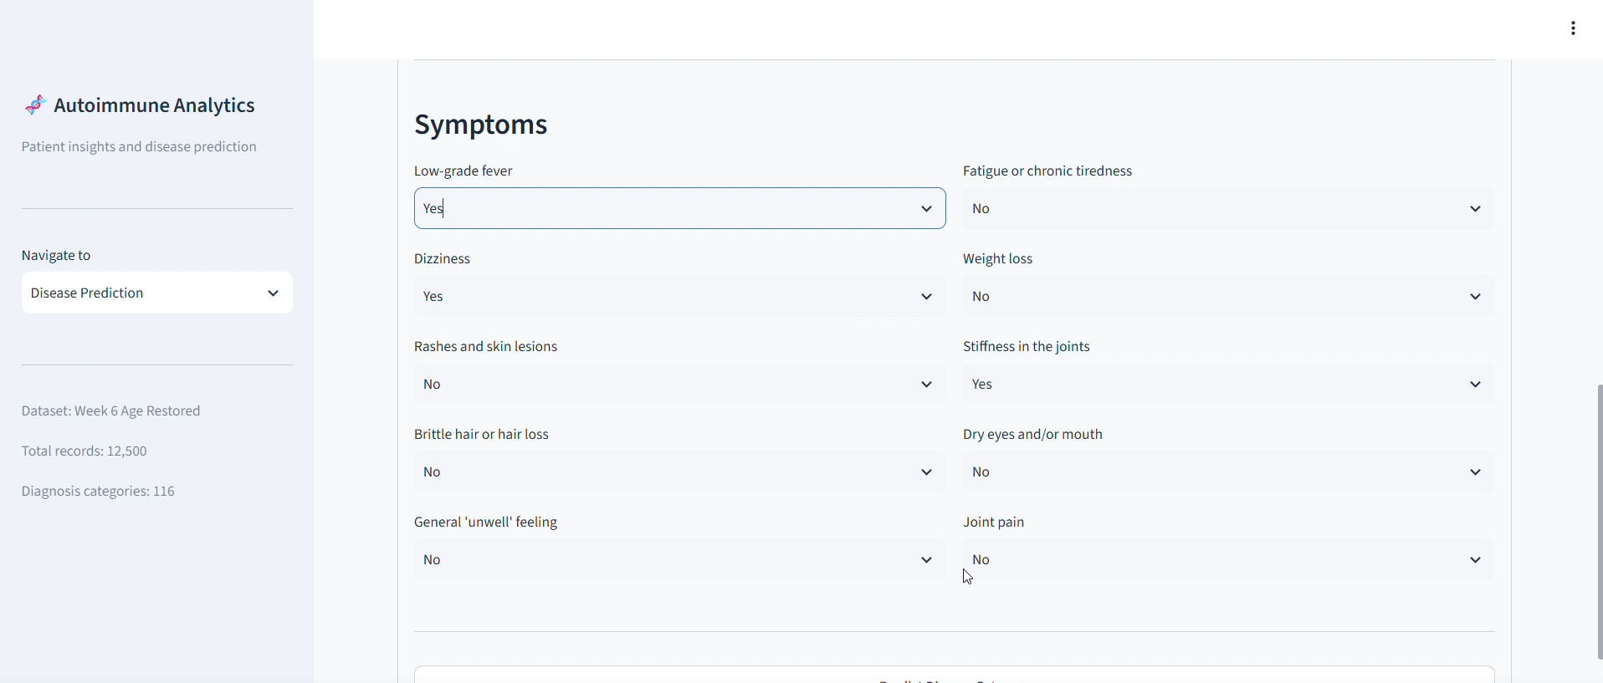
Figure 4. Symptom inputs in the prediction interface.
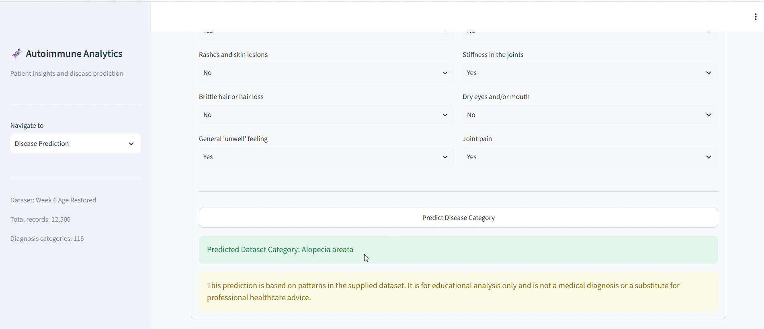
Figure 5. Example prediction result and educational-use disclaimer.

6. Methodology and Implementation

6.1 Data loading and preparation
The app loads the CSV through a cached data-loading function, strips whitespace from column names, and checks for required Age and Diagnosis columns. A helper locates columns without relying on capitalization.

6.2 Feature organization
Symptoms, selected clinical features, antibody markers, and patient-information fields are defined in separate lists. Only columns present in the dataset are used, and duplicate prediction features are removed.

6.3 Interactive visualization
Plotly Express creates the diagnosis bar chart, age histogram, symptom-frequency chart, symptom heatmap, clinical box plots, and antibody-marker comparison. Streamlit renders the charts responsively.

6.4 Prediction workflow
The code imports scikit-learn utilities for train/test splitting, preprocessing, categorical encoding, imputation, Random Forest classification, and evaluation metrics. The interface prepares user-entered demographic, clinical, and symptom features for prediction.

6.5 Interface design
The app uses a wide layout, expanded sidebar, metric cards, tabs, select boxes, and a restrained light-blue theme. Navigation includes Overview, Symptom Analysis, Clinical Analysis, and Disease Prediction.

7. Results and Discussion
Component | Insight conveyed
Overview metrics | Dataset scale and high-level context
Diagnosis bar chart | Relative counts for leading diagnosis categories, excluding Normal
Age histogram | Distribution of ages represented in the dataset
Symptom frequency chart | Percentage of records reporting each symptom
Symptom heatmap | Comparative symptom patterns among frequent diagnosis groups
Clinical box plot | Median, quartiles, spread, and variation of a selected variable by diagnosis
Antibody marker chart | Selected marker values compared across diagnosis groups
Prediction interface | Category output from user-provided values; educational exploration only

Interactive selection is a key strength: the user can change the symptom or clinical feature under study without needing a separate static chart for every variable. The screenshots document the integrated dashboard. No video player controls or timestamps are included in the report.

8. Limitations and Future Enhancements

8.1 Limitations
- The feature-engineered dataset is intended for project analysis; patterns should not be interpreted as clinical evidence.
- A displayed prediction is not a medical diagnosis and cannot replace professional healthcare advice.
- A single example prediction does not establish accuracy, generalization, or reliability.
- Diagnosis categories may be imbalanced; comparisons should consider group sizes.
- Visual associations do not establish causation.

8.2 Future enhancements
- Add a model-performance page with held-out accuracy, macro-F1, class-wise precision/recall, and confusion matrix.
- Add diagnosis filters and class counts to analytical charts.
- Add download controls for filtered data and chart images.
- Add input validation, missing-value guidance, and reset-to-default controls.
- Document training configuration, random seed, and split details.

9. Conclusion
The Week 8 dashboard integrates dataset summaries, diagnosis and age distributions, symptom analysis, clinical feature exploration, and an interactive prediction interface into one Streamlit application. Plotly supplies responsive visualizations, while the navigation structure guides users from overview to deeper analysis. The project demonstrates how dashboard storytelling can make a complex dataset easier to explore. Future work can strengthen the application with model evaluation, additional filters, and export capabilities.

10. References
- Streamlit documentation — https://docs.streamlit.io/
- Plotly Python documentation — https://plotly.com/python/
- Scikit-learn documentation — https://scikit-learn.org/stable/
- Pandas documentation — https://pandas.pydata.org/docs/
- Team 12 project source: DSV_DashBoard.ipynb and Week 6 Age-Restored Feature-Engineered Dataset.

